Chair, EverGreen Agriculture Partnership
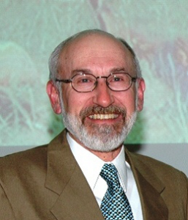 | Dr. Dennis Garrity was the former Director General of The World Agroforestry Centre (ICRAF) (2001-2011) and the current Drylands Ambassador for the United Nations Convention to Combat Desertification Drylands (UNCCD). He chairs in the Steering Committee for Landcare International, as well as the EverGreen Agriculture Partnership. Dr. Garrity is a systems agronomist whose career has been focused on the development of small-scale farming systems.  He served as the Regional Coordinator of the Southeast Asia Programme of the World Agroforestry Centre, based in Bogor, Indonesia, and was the head of the Agroecology Unit at the International Rice Research Institute (IRRI) in the Philippines. Dr. Garrity has a PhD in crop physiology from the University of Nebraska.
Partnership Manager
Alice Muller has worked with Dennis to develop partnerships and activities to support the scaling up of EverGreen Agriculture for the last 2 years. Alice has a background in Environmental Science and Social Research in Australia. In this role, which brought her to Kenya, she oversees the running of the EverGreen Agriculture Partnership and all the good things that we get up to! | 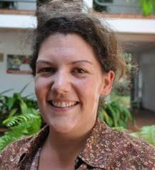
Senior Science Policy Advisor
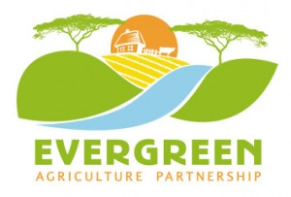 | Patrick Worms, our Senior Science Policy Adviser, is based in Europe and is working especially on building up our Evergreen Agriculture platform.
Partnership Business Model Consultant
Sid Mohan is working with the Partnership to develop business models, and information management and analysis systems. Sid uses his creative side to provide content and advice for the Partnership’s communications products and website. | 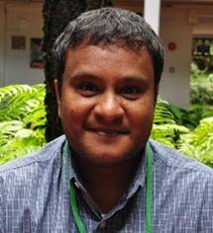
Research Fellow
 | Erick Otieno assists in collating all scientific based evidences and reviews on EverGreen Agriculture. He facilitates in creating the science to scaling up EverGreen Agriculture (with a focus on fertilizer trees) in crop fields, developing extension materials for EverGreen Agriculture systems as well as in building strong partnership with various partners and farmer groups for the scaling up programmes. Erick holds BSc. Forestry from Moi University and currently pursuing MSc. Environmental science at Kenyatta University with special interest in Evergreen Agriculture, fertilizer trees in particular.
Administrative Assistant
 | Winnie Achieng’ assists in the effective coordination and development of the EverGreen Agriculture Partnership agenda through contributing to the completion of secretariat tasks as well as the development of processes and foundations of the secretariat operations.  She provides valuable administrative, operational and Human Resource support to the Partnership by working on specific projects in EVAP scaling up activities and acts as a liaison between the Partnership team and other colleagues. Winnie has a background in Business Administration (Human Resource Management) and is experienced in various administrative and logistical capacities with a good command of management practices.
Extensionist Ethiopia
Niguse Hagazi is based in ICRAF Ethiopia and is the National Faidherbia Consultant in the Ethiopia office. Niguse has a background in Forestry Science and Tropical Land Resources Management. He has research and teaching experience that dates back to 2002 and has been involved in an impressive number of research publications and manuals. His vast experience in supporting extension services makes him an invaluable part of the team.

Communication Consultant
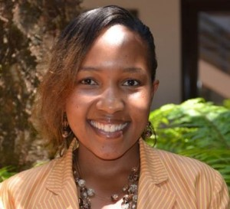 | May is a young communicator extraordinaire hailing from Jomo Kenyatta University of Agriculture and Technology. Her background is in Public Relations and Corporate communication. In addition to managing the communications of the Evergreen partnership, May has a particular interest in grassroots instituional arrangements, policy processes, rainwater harvesting and the participation of youth and women in agricultural decision making in Sub-Saharan Africa.
Landcare International and Africa Landcare Coordinator
Clinton has a background in Resource Economics, Natural Resource Management and Agricultural Extension Systems in both Australia and East Africa. Currently coordinating both the Africa Landcare Network and Landcare International, Clinton has a particular interest in community mobilization and participatory engagement through the Landcare approach. in addition to work in grassroots institutional arrangements, Clinton also has a particular interest in Land Restoration approaches, Institutional Policy, Water Management and Climate Smart Agriculture practices. | 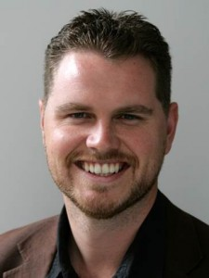
Economics Consultant
Youth in Business Consultant
Pastoral Land Restoration Consultant
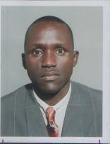 | Lionel Lepalo Gideon, a Native of Lake Turkana and and Environmental/ Peace Activist with vast knowledge on Community Development and Media Background as well as being a regular contributor to the local news outlets on the Environmental and Cultural Stories on northern frontier districts of Kenya. A Conservationist at heart and a grassroots mobilizer whose dream is to empower communities in seeking solutions to local challenges. Fondly referred to as Lion, by his peers, co-authored a write up with Prof. Nigel Nicholson of London School of Business (On The Leadership Lessons Of The Maasai).
Intern

